**Table of Contents**

Executive Summary ................................................................................................................... 3

Company Description ................................................................................................................ 4

Strategic Focus and Plan ............................................................................................................ 4

Situation Analysis ...................................................................................................................... 6

Industry Analysis through Health and Nutrition concerns ............................................... 10

Market-Product Focus ............................................................................................................. 16

Marketing Program ................................................................................................................... 17

Product Strategy .......................................................................................................... 17

Pricing Strategy ............................................................................................................ 17

Promotion Strategy ...................................................................................................... 17

Place/distribution strategy ............................................................................................ 18

Financial Data and Projections ................................................................................................ 18

**1. EXECUTIVE SUMMARY**

Lunchables is one of the leading brands in the Kraft-Heinz company. Lunchables has been and will remain a well-loved and popular lunch option for children and families. Now, the brand is breaking into the breakfast industry with their new product, Breakfastables. Breakfastables will include 3 different sizes and 3 meal combinations that are sure to put a smile on busy parents’ and kids’ faces all over the U.S. This business plan will highlight the marketing, branding, and financial goals that Breakfastables hopes to reach in the next 3 years.

Breakfastables advertising will be targeted to busy families with elementary school aged children. Lower-, middle-, and upper-class families will be able to afford our products. There are plenty of meal combinations and sizes so that every kid can find something they enjoy.

Breakfastables will remain affordable by using a competitive at-market strategy. We expect to reach profitability in the first year due to the current and consistent popularity of Lunchables. Below are the estimated profits for the first 3 years.

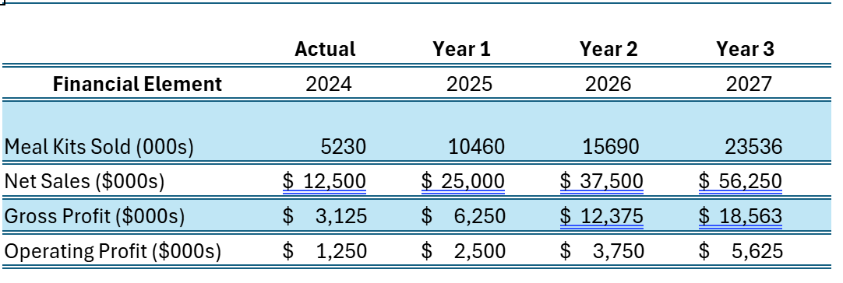***Objectives***

The objectives for the first 3 years include:

1. Achieve distribution in at least 45% of retail stores where Lunchables are sold within the first year.
2. To be among the top 3 on-the-go breakfast meals for consumers by the end of the third year.
3. Achieve a gross profit margin of 25% by the turn of the second year.

***Mission***

The mission of Kraft Heinz Company is to nourish the world sustainably and ethically by creating high-quality foods that support a healthy lifestyle and a thriving planet.

***Keys to Success***

* Market alongside Lunchables to familiarize consumers and encourage brand loyalty
* Incorporate competitive at-market pricing to drive sales and remain affordable
* Target advertisements in channels popular with children and families (YouTube, TikTok, Disney, etc.)

**2. COMPANY DESCRIPTION**

The Kraft Heinz Company was formed in 2015 when the Kraft Foods Group and Heinz Holding Corporation merged. It is one of the largest food and beverage companies in the world with locations in more than 40 countries, bringing in 26 billion dollars in sales in 20221. Kraft Heinz includes brands such as Caprisun, Lunchables, Kool-Aid, Velveeta, and more.

Lunchables were first introduced in 1988 with convenient and ready-to-go meals, starting with assortments of crackers, meats, cheeses, and a dessert. Over time, Lunchables expanded and added other meal options such as pizza, nachos, chicken nuggets, sandwiches, and more. Lunchables are recognized and loved by children, bringing in sales of 1.8 billion dollars in 2022, which made up 8.6% of Kraft Heinz total sales2. With Lunchables popularity and continuous success, Kraft Heinz has decided to introduce a new breakfast option to the Lunchables brand: Breakfastables.

Breakfastables will be a new line of ready-to-eat breakfast kits that will save families time in the morning and make breakfast fun and easy. Breakfastables will include hash browns, 2 mini bagels with cream cheese, a mixed assortment fruit cup, and an orange juice Caprisun. This marketing plan highlights our company’s plans, goals, and missions.

**3. STRATEGIC FOCUS AND PLAN**

This section covers three aspects of corporate strategy that influence the marketing plan: (i) the mission, (ii) goals, and (iii) core competency/sustainable competitive advantage of the Kraft Heinz Company and Breakfastable.

**i. Mission**

The mission of Kraft Heinz Company is to nourish the world sustainably and ethically by creating high-quality foods that support a healthy lifestyle and a thriving planet.

**ii. Goals**

For the coming three years, the Breakfastable brand of the Kraft Heinz Company projects to achieve the following goals:

***Nonfinancial Goals:***

1. Achieve distribution in at least 45% of retail stores where Lunchables are sold within the first year.
2. To add two additional meal offerings by the end of the first year.
3. By the end of the second year, expand the targeted market to teens and young adults with different meal offerings
4. To be among the top 3 on-the-go breakfast meals for consumers by the end of the third year.
5. To become leaders in utilizing sustainable packaging within the first six months of releasing Breakfastable.

***Financial:***

1. To add $25M to Kraft Heinz's net sales by the end of the first fiscal year of product launch.
2. Achieve a gross profit margin of 25% by the turn of the second year.
3. Achieve an operating profit margin of 10% by the end of the third year.

***iii. Core Competencies and Competitive Advantage***

In terms of core competencies, Breakfastable benefits from Kraft Heinz’s extensive distribution network, which enables swift placement of our product on shelves in major retail and grocery stores. Kraft Heinz, by nature of its scale, is also skilled at producing compartmentalized meals cost-efficiently. With their extensive manufacturing capabilities, they can afford to produce more Breakfastables at lower unit cost3. Additionally, as an extension of the well-known Lunchables brand, Breakfastable gains that strong name brand recognition and a loyal customer base. By using that name recognition, we will easily be able to get customers to try Breakfastable and let the quality product speak for itself.

**4. Situation Analysis**

This situation starts with a snapshot of the current environment in which The Kraft Heinz Company finds itself by providing a brief SWOT (strengths, weaknesses, opportunities, threats) analysis. After this overview, the analysis probes ever-finer levels of detail: industry, competitors, company, and consumer.

**SWOT Analysis**

Figure 1 reflects the current environment that Kraft Heinz and subsidiaries compete in. A SWOT analysis is used to display its current strengths, weaknesses, opportunities and threats from internal and external factors regarding the launch of Breakfastables.

**Figure 1. SWOT Analysis of Kraft Heinz Company**

|  |  |
| --- | --- |
| **STRENGTHS** | **WEAKNESSES** |
| * Brand Recognition will guarantee a customer base * Use of Products already in Portfolio * Use of established distribution network | * Portfolio Brand Products shipped to packaging location * Limited Customer Base * Use of plastic is becoming less acceptable and Green initiatives are becoming more prominent |
| **OPPORTUNITIES** | **THREATS** |
| * Creation of on the go breakfast packs similar to P3s * Expansion to include other brands under the Kraft Heinz Portfolio * Creation of “Fresh” or “Healthy” Breakfastable * Limited time collaborations with other well known Portfolio brands | * Market trending towards healthier options * Most products will use preservatives, potentially affecting quality * Expanding to a new market introduces competition that has more experience in the breakfast food space |

The Breakfastable product has many positives that will add to the success of launching this new product compared to the downside risks. First, Kraft Heinz already has a similar product within the portfolio with Lunchables, with a Breakfastable spin-off kids will already recognize the label and be curious about the product. Kraft Heinz is a multi-billion-dollar brand with market recognition around the world. Incorporation of other well-known portfolio brands will give Breakfastables instant credibility and customers will already be familiar with some products,

such as Philadelphia Cream Cheese. This kind of synergy could potentially be very useful. Using existing products will reduce R&D costs and allow existing supply chains to be integrated into the product. Plus, Kraft Heinz has already established relationships with grocery stores and shops nationwide.

One major threat to Breakfastables is the industry and consumer trend shifting towards healthier or fresh products. Breakfastables will be heavily processed and contain preservatives to ensure a longer shelf life. Kraft Heinz should explore the ability to create healthier Breakfastables or at least minimize preservatives. This will help us expand our offerings to more health-conscious customers. There is also market demand for an “on the go” or snack-sized Breakfastable to compete with other snack-sized options such as P3. Another potential problem is the concern about saturation in the breakfast meal space. While Lunchables commands a respectable market share, Breakfastables will enter a new breakfast market with strong competition, like Johnsonville Foods, Bob Evans, and Banquet Foods. Strong advertising and positive word-of-mouth could help Kraft Heinz overcome this problem.

**Industry Analysis: Trends in Breakfast and Prepared Food**

**Prepared Food.** As of 2024, Kraft Heinz is a leading manufacturer of prepared meals and currently owns 5.4% of market share4.Due to the normalization of returning to work, there has been an increased demand for prepackaged meals that are convenient and easily prepared. The primary demographics driving this demand are Gen Z and Millennials5. The market size of prepared meals is expected to be $19.7 billion in 20244.This is a change from the past few years that have seen the prepared meal segment slow and go negative,-1%, in 20246. This has primarily been driven by overall inflation costs that have caused consumers to become more budget conscious. Moving forward, there is expected to be greater demand and a return to growth with an 11% increase of sales from 2024 to 20294.

**Breakfast Food.** The growing success of the breakfast food sector can be attributed to research linking breakfast consumption with reduced risks of chronic conditions and the rising consumer demand for convenient, nutritious, and portable meal options. As more individuals prioritize health and seek out easy, on-the-go choices, the demand for convenience foods has surged. These ready-to-eat products, designed for quick consumption, are becoming increasingly popular due to higher disposable incomes, greater health awareness, and a preference for hassle-free meals. Consequently, the breakfast food market is projected to maintain robust growth, with a compound annual growth rate (CAGR) of 6.3% over the coming years7.

**Figure 2. Sales Projections for prepared meals through 2029A graph showing a green line

Description automatically generated**Overall, there has been a shift towards fresh or more healthy choices within the prepared meal segment.This has been particularly driven by consumers between the ages of 18-54 with an emphasis on plant-based options and ingredients containing less preservatives4.This would allow for Breakfastable to expand its product offerings to capture these customers. There has also been a sentiment change towards prepared meals that are now seen as healthy or healthy alternatives to home cooked meals.

**Competitor Analysis:**

**Figure 3. 2024 Revenue by Company, Frozen/Packaged Foods8**

Heinz faces several strong competitors: Nestle has a variety of products, including cereal bars and breakfast sandwiches, General Mills with its breakfast cereals, Conagra, and PepsiCo, which owns Quaker Oats. The breakfast food market has split because of an increasingly health-conscious market. LUNCHLY LLC has launched a Lunchables alternative that is marketed as being healthier. Frozen meal options like Lean Cuisine, Healthy Choice, and Thrive also position themselves as healthy and have reduced market share. None of these brands have focused on breakfast foods, offering Heinz Kraft a competitive advantage in that space.

**Company Analysis**

The Kraft Heinz Company is the third largest marketer and manufacturer of food and beverages all across North America. The company brings in 26 billion dollars in net sales annually. They own 70 factories worldwide9.

Kraft Heinz has a strong focus on product innovation and sustainability. They are committed to financial stability and long-term value, which increases positive relationships and benefits with their shareholders. The company has a passion for digital transformation that positions them for future growth9.

**Customer Analysis**

**Customer Characteristics:**

On any given day, 85% of adults aged 20 years and older consume one or more foods and/or beverages at breakfast. Adults over the age of 60 are by far the most likely to consume breakfast as compared to 20-39 and 40-59 year olds. Adults in the middle- and highest- family incomes are the most likely to consume breakfast regularly as compared to those in the lowest family income category10.

Some consumers are driven to eat breakfast in order to wake up and get energy for the day as most people would agree with the sentiment that there is nothing like a good breakfast to start your day off right. Of those consumers many choose options which are the most convenient and easy to prepare11.

**Health & Nutrition Concerns:**

Many adults are trying to lead healthier lifestyles and are looking for ways to cut out higher sugar diets. Among all adults, intake of energy, protein, dietary fiber, total fat, and saturated fat is higher for breakfast consumers than for non-consumers. Conversely, added sugar intake is lower among consumers. Many adults may also consume breakfast for the energy it provides. About one-fifth of daily energy is consumed at breakfast, as well as about 20-25% of daily intake of food components and nutrients. Overall Breakfastables will appeal to American households because of the convenience and appeal to health-conscious consumers10

8**. Market Product Focus**

This section lays out the three-year marketing and product objectives for Kraft-Heinz and the target markets, points of difference, and positioning of its lines of Breakfastables.

**Marketing and Product Objectives**

Lunchables’ marketing intent is to build off its current consumer base and target busy families with elementary aged children. These are detailed in three areas below:

* Current markets: Current markets will be utilized by marketing Breakfastables with Lunchables. This could include deals where if families purchase, for example, 2 Lunchables, they get a Breakfastable for free or half off. This will introduce our current market to our new product.
* New markets: New markets can be reached by targeting retail companies that open early in the morning, such as gas stations, coffee shops, or 24/7 convenience stores. This would allow Breakfastables to break into the market of early risers on their way to work or who are travelling.
* New products: To begin, Breakfastables will start with 3 sizes of 3 different meals: 1. bacon, bagel, and berries, 2. waffles and yogurt, and 3. bagel with cream cheese and apple slices. Each includes orange juice. New product screening will occur during year 1 to learn what new meal combinations consumers are excited about. New meals will be brough to market in years 2 and 3.

**Target Markets**

The primary target for Breakfastables is busy families with children that are elementary school aged. These households contain busy parents who are short on time in the morning. They may not have time to make a healthy breakfast for one or multiple children before school. These families need a quick, healthy, and delicious alternative to breakfast that their children will enjoy. These families can range anywhere from lower, middle, or upper class because Breakfastables will be affordable and have multiple options that will appeal to all children.

**Points of Difference**

The “points of difference” - characteristics that make Breakfastable unique relative to competitors - fall into three important areas:

* Health focused meals. Many competitors which exist in the “on the go” breakfast field focus too much on being convenient and end up consisting of unhealthy meals created only with taste in mind, while Breakfastables takes a wholistic approach to breakfast focusing on nutrition as well.
* Availability. Breakfastables will focus on being available in locations which open early in the morning such as gas stations, coffee shops, or convenience stores so that you can get your breakfast when you want it in a location that’s convenient for you.
* Unique packaging. Breakfastables packaging incorporates the Lunchables packaging customers know and love and adds its own spin to it, incorporating fun animals for children and using recycled materials to promote our sustainability.

**Positioning**

For caretakers of grade school children, Breakfastables by Lunchables offers a nutritious, grab-and-go breakfast solution for busy mornings. Unlike other breakfast choices, only Breakfastables offers a fun, kid-approved combination of ingredients portioned to fuel kids for their day. With Breakfastables, you can give your child a breakfast they’ll love- and feel great about it- no matter how hectic the morning gets.

**9. Marketing Program**

**Product Strategy**

This section contains information on the product line, product quality and product packaging.

**Product Line:**

Breakfastables will contain individual breakfast meals for children. They will be served in recycled cardboard boxes with plastic trays inside that will weigh ~9.5oz. Initially, we will start with serving 2 different Breakfastable meal options, bagel & cream cheese with blue berries and apple juice, protein enriched pancakes with syrup, yogurt, and orange juice. We will expand the line as time passes to include products such as bagel, bacon and cheese breakfast sandwich with apple slices and cranberry juice.

**Unique Product Quality:**

Breakfastables edible contents will be created and formulated by the same amazing team of chefs and nutritionist that brought Lunchables to market. Every Breakfastable will contain fresh and never frozen all natural ingredients to ensure that that every meal provides the nutrition and great taste every kid deserves and needs to keep them moving all day long. This includes no use of preservatives, artificial flavors or artificial food dyes.

**Packaging:**

Each individual package will include a protein or protein enriched component, a yogurt or fruit and a juice box. Use of recycled plastic/cardboard to create the Breakfastable tray to reduce environmental impact of packaging and promote Breakfastables commitment to a sustainable future. Breakfastables will use an easy to open cardboard box with a sealed plastic tray inside which has become synonymous with the Craft Heinz Lunchables brand. Packaging will include vibrant red theme paired with cartoon animals or characters to associate different Breakfastable meals to different meal options such as cartoon panda packaging with panda head shaped pancakes within the meal to create a lasting impression and excitement for eating breakfast in children.

**Price Strategy**

Breakfastables will be priced at $3.19, comparable to other Lunchables products in the 10oz size range. At 9.5 oz per Breakfastables meal, this amounts to about $0.34 per oz. This is a competitive at market pricing strategy. Lunchables is already the category leader, so there is no reason to price it lower than current Lunchables products, which could cannibalize existing sales, and since it is not a “premium” product there is no reason to price it higher than current offerings. We view it as a product comparable to a standard 10oz Lunchables meal, only formulated with more breakfast-friendly offerings.

**Promotion Strategy**

Key promotion programs feature advertising through child-focused media, coupons, in-store demonstrations and partnerships with family-oriented spaces.

**Advertising:** Child-friendly platforms such as Nickelodeon, Disney Channel, and YouTube Kids’ channels will be used to create awareness. Colorful and engaging commercials will highlight the fun and nutritious aspects of Breakfastables, resonating with kids.

**In-Store Demonstrations and Family Partnerships:** Demonstrations in grocery stores near the grab-and-go sections will provide consumers with an opportunity to sample Breakfastables, while partnerships with family-oriented spaces, such as children’s hospital cafes, daycare centers, and after-school programs, will integrate the product into snack and breakfast offerings. These initiatives build goodwill with families, highlight the nutritional value of Breakfastables, and emphasize its convenience as a go-to option for busy mornings.

**Coupons and Promotional Codes:** To encourage trial and repeat purchases, coupons will be distributed in three ways:

1. **On Lunchables Packaging**: Each Lunchables box will feature a coupon offering $1.50 off a Breakfastables purchase, leveraging cross-brand trust and loyalty.
2. **In-Store Displays:** Bright, engaging displays near the Lunchables section will feature coupons to encourage cross-category purchases.
3. **Online Promotions:** Digital coupons will be available through the Breakfastables social media channels. Customers can print these coupons or access promo codes for in-store or online grocery purchases.

**Place/Distribution Strategy**

Lunchables products – through food distributors – are sold at all major grocery chains, retailers, as well as to schools through programs like the National School Lunch Program. This has been very successful for Kraft Heinz and Lunchables in the past, so we intend to continue this strategy as well as work with grocers for Breakfastables to be stocked in breakfast food aisles at their stores.

**Financial Data and Projections:**

**Sales Revenue**

Over the previous years, Lunchables have been on a downward decline in their gross sales. With the addition of Breakfastables, we aim to capture a larger customer base and reverse this previous trend. The figure below shows Lunchables gross sales from 2016-2020.

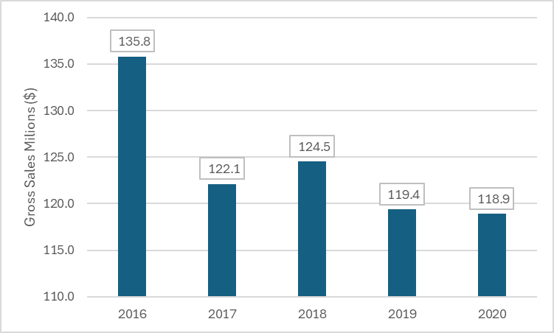

**Three Year Projections**

The three-year projections for Breakfastables appear below. These projections reflect the expected growth trajectory of Breakfastables.

|  |  |  |  |  |
| --- | --- | --- | --- | --- |
|  | **Actual** | **Year 1** | **Year 2** | **Year 3** |
| **Financial Element** | 2024 | 2025 | 2026 | 2027 |
| Meal Kits Sold (000s) | 5230 | 10460 | 15690 | 23536 |
| Net Sales ($000s) | $ 12,500 | $ 25,000 | $ 37,500 | $ 56,250 |
| Gross Profit ($000s) | $ 3,125 | $ 6,250 | $ 12,375 | $ 18,563 |
| Operating Profit ($000s) | $ 1,250 | $ 2,500 | $ 3,750 | $ 5,625 |

